Practical No. 1

Aim: Google and whois reconnaissance
- Use google search techniques to gather information about a specific target or organization.
- Utilize advanced search operators to refine search results and access hidden information.
- Perform whois lookups to retrieve domain registration information and gather details about the target’s infrastructure.

Web crawler:
A web crawler, spider, or search engine bot is a software program that accesses, downloads, and/or indexes content from all over the Internet. Web crawler operators may seek to learn what (almost) every webpage on the web is about, so that the information can be retrieved when it's needed. Search engine operators may use these bots to find relevant pages to display in search results. The bots are called "web crawlers" because crawling is the technical term for automatically accessing a website and obtaining data via a software program.

Google reconnaissance:
Google reconnaissance, often referred to as Google hacking or Google dorking, is the practice of using advanced search operators and syntax in the standard Google Search bar to uncover hidden, exposed, or difficult-to-find information online.

Questions:
Q. What is reconnaissance in cybersecurity?
→ Reconnaissance in cybersecurity is the process of collecting information about a target system, network, or organization before an attack or security assessment. It helps identify potential vulnerabilities, entry points, and valuable information that can be used for further actions.

Q. What is Open Source Intelligence (OSINT)?
→ Open Source Intelligence (OSINT) is the process of collecting and analyzing information from publicly available sources such as websites, social media, news articles, and public records. It is used in cybersecurity to gather information about a target without directly interacting with its systems.

Q. What is Google Reconnaissance (Google Dorking)?
→ Google Reconnaissance (Google Dorking) is a technique that uses advanced Google search operators to find specific information that is publicly available but not easily accessible. It helps security researchers identify exposed files, login pages, or sensitive information indexed by search engines.

Q. What is a WHOIS lookup?
→ A WHOIS lookup is a method of retrieving publicly available information about a domain name, such as its registration details, registrar, creation date, and expiration date. It is commonly used in cybersecurity and domain investigations.

Q. What information can be obtained from a WHOIS database?
→ A WHOIS database provides registration details of a domain name, such as the domain owner’s name/organization, registrar, registration and expiry dates, and name server information. It may also include contact details like email, though often these are hidden or privacy-protected.

Q. What is domain registration?
→ Domain registration is the process of reserving a unique domain name (such as example.com) with an accredited domain registrar for a specific period of time, giving the registrant the legal right to use that domain on the internet, subject to renewal.

Q. What is the purpose of reconnaissance in ethical hacking?
→ In ethical hacking, reconnaissance is the process of collecting information about a target system, network, or organization before an attack simulation.
Its purpose is to identify possible entry points, understand system weaknesses, and gather details like IP addresses, domain names, technologies used, and employee information.

Q. Differentiate between active and passive reconnaissance.
Basis | Passive Reconnaissance | Active Reconnaissance
Interaction | No direct interaction with target systems | Direct interaction with target systems
Detection | Very hard to detect | Easily detectable by security systems
Sources used | Public sources like websites, WHOIS, social media | Live systems like servers, networks, ports
Risk level | Low risk and safe | Higher risk due to interaction
Examples | Google search, OSINT, public records | Port scanning, ping sweeps, network probing

Table:
Operator | Purpose | Example
site: | Search only within a specific website or domain. | site:infosys.com,  site:rbi.org.in
filetype: | Find specific file formats like PDF, PPT, DOC, XLS, etc. | site:rbi.org.in filetype:pdf
intitle: | Finds pages with a keyword in the title. | intitle:"Login"
inurl: | Finds keyword inside the URL. | site:netflix.com inurl:admin
cache: | It is used to view the cache pages. | cache:amazon.com
related: | Finds websites that are similar or related to a given website. | related:samsung.com

Screenshots:

- Site:
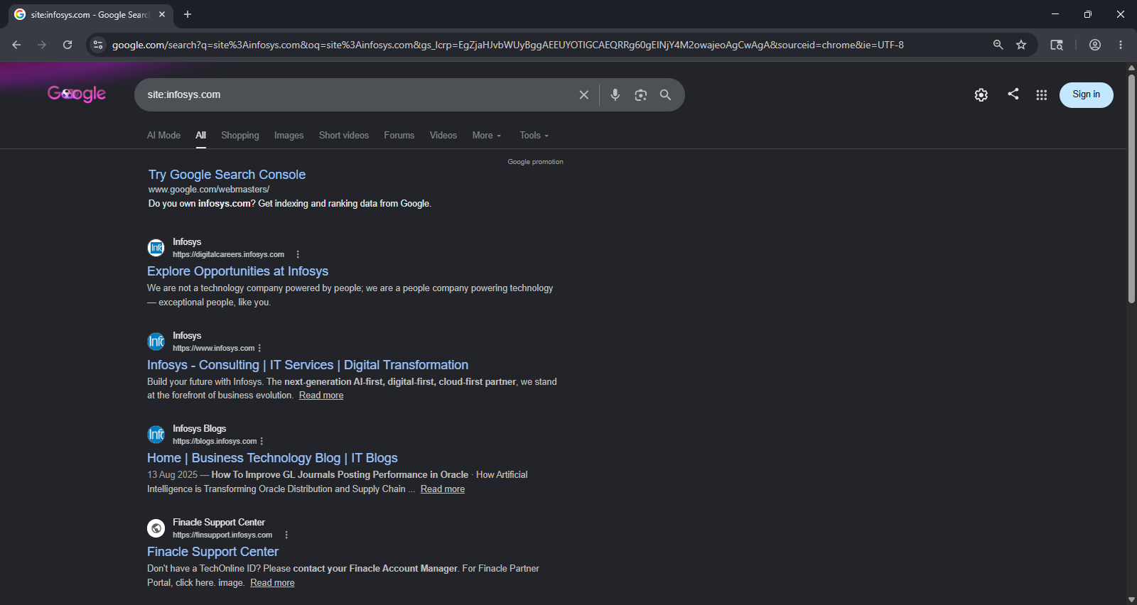

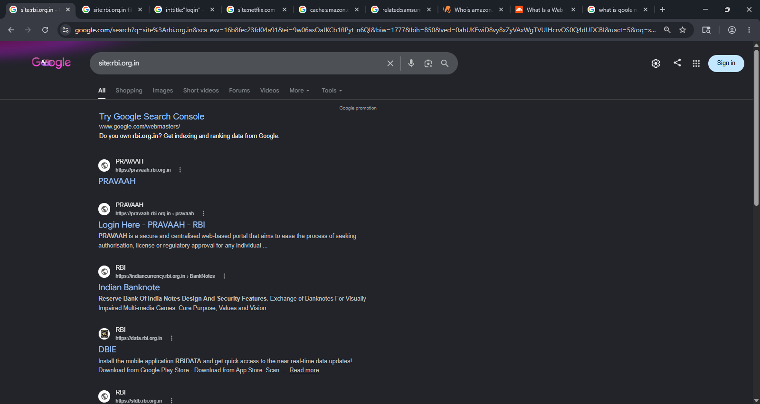

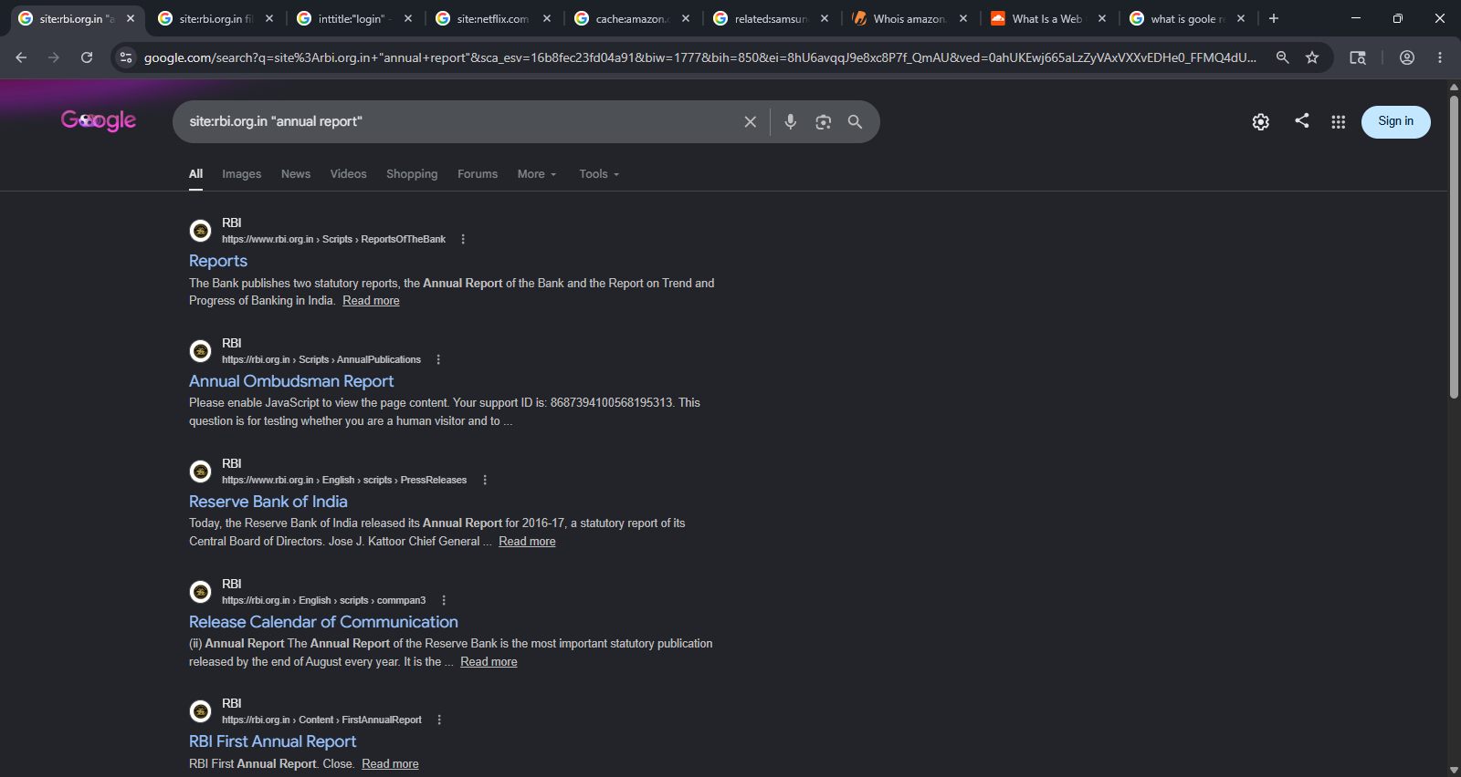

- Filtetype:
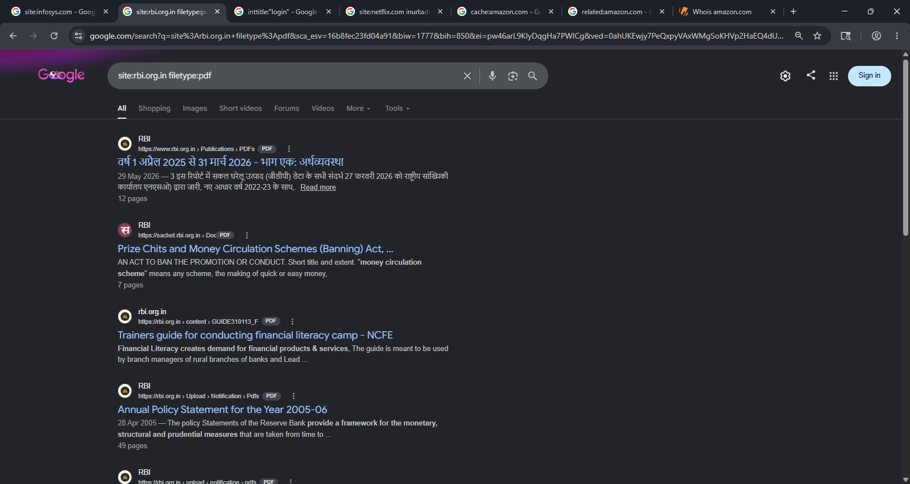

- Intitle:
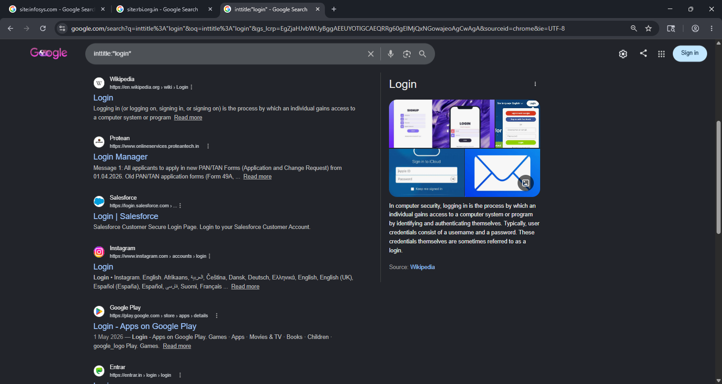

- Inurl:
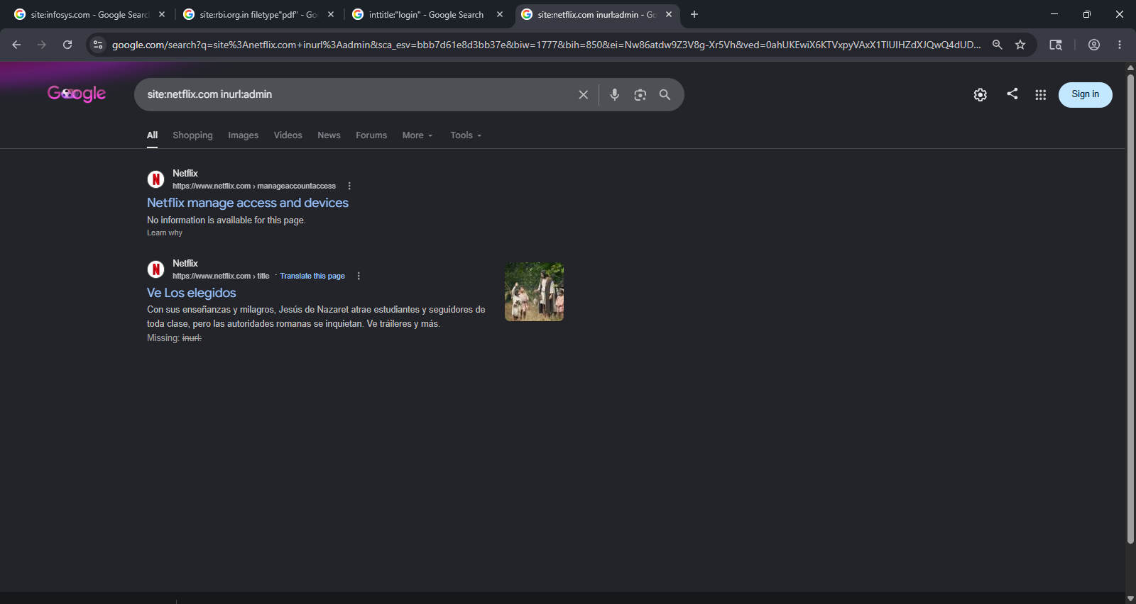

5. Cache:
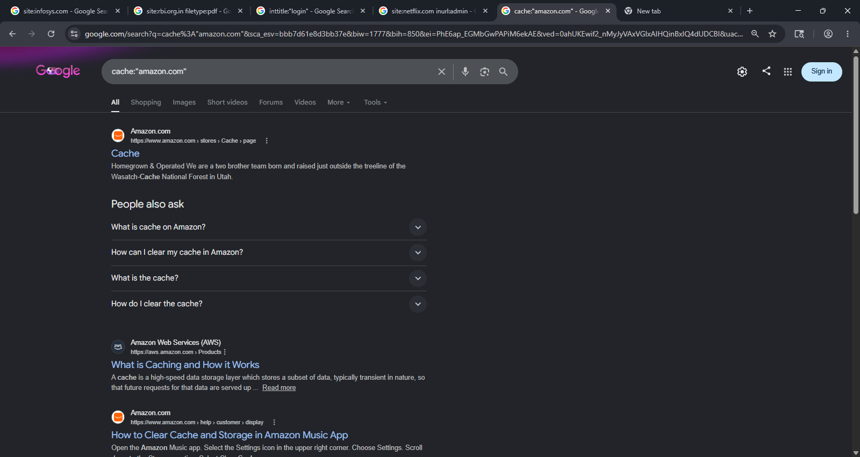

6. Related:
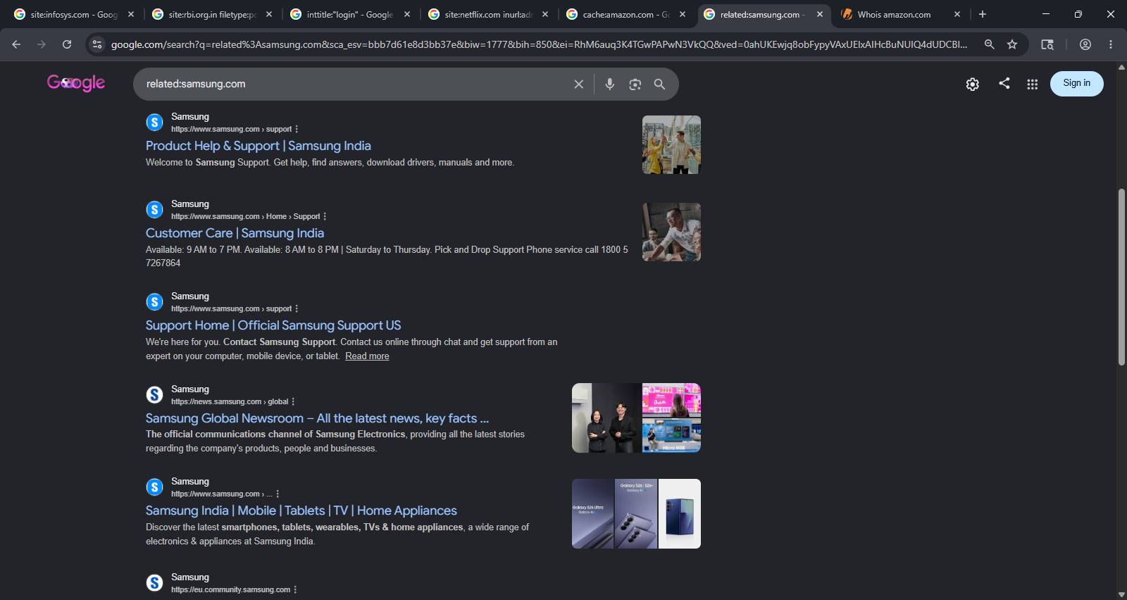

WHOIS

